**GitHub Copilot Activation process**

**Guideline**

## **Activate** **GitHub Copilot**

1. Login into the Url [https://github.com/enterprises/CognizantGitHubCopilot](https://github.com/enterprises/CognizantGitHubCoPilot)

Once access has been granted, you will see the above screen with “continue” button.

**2**: Click on Continue

You will be redirect to the below screen.

**3**: Open Visual Studio Enterprise/Professional or VS Code and make sure GitHub is connected with your Cognizant AssociateId to enable the Copilot license. Please avoid connecting GitHub with your personal or any other email IDs.

Refer the supported IDE for Copilot - [Configuring GitHub Copilot in your environment - GitHub Docs](https://docs.github.com/en/copilot/configuring-github-copilot/configuring-github-copilot-in-your-environment)

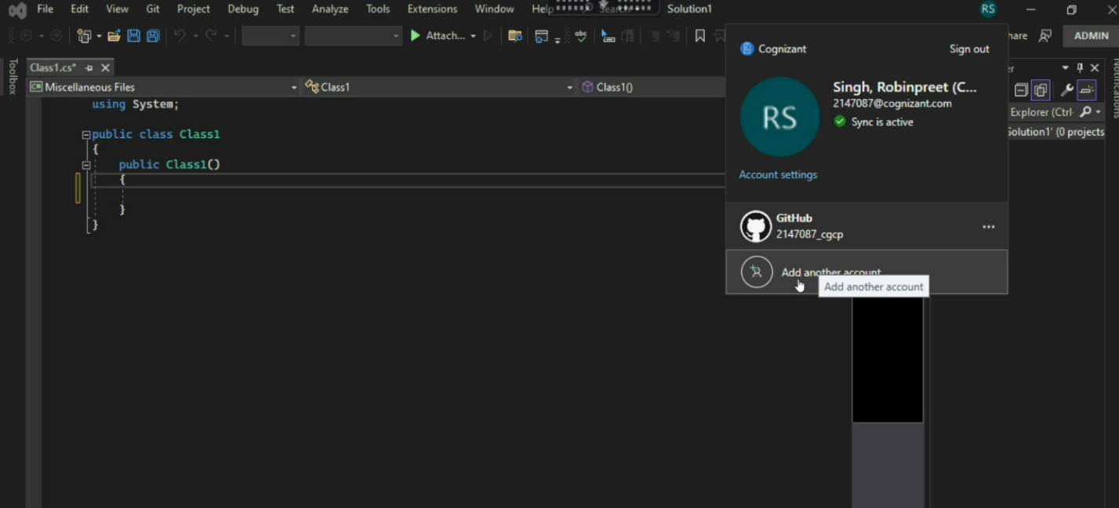

## **Queries through Live Support GSD**

Below queries can be addressed through Service now ticket via Live support GSD process.

|  |  |
| --- | --- |
| **Keywords to raise the Service now ticket** | **Prerequisites** |
| Unable to access Github Copilot | Please make sure you have the below details.  ServiceNow Request ID * : Screen shot of the confirmation from IT infra team on access provision * : |
| Error while accessing Github Copilot | Please make sure you have the below details and Visual Studio IDE should be upgraded to latest version using Visual Studi Installer.  ServiceNow Request ID * : Screen shot of the confirmation from IT infra team on access provision * : |

## **Training Video links**

1. GitHub Copilot – K-point session

[https://cognizant.kpoint.com/web/videos/gcc-6fe8aaf5-6b28-46d0-805b-56ce8da1c0d1](https://apc01.safelinks.protection.outlook.com/?url=https%3A%2F%2Fcognizant.kpoint.com%2Fweb%2Fvideos%2Fgcc-6fe8aaf5-6b28-46d0-805b-56ce8da1c0d1&data=05%7C01%7CSunilkumar.P%40cognizant.com%7C9e0babc9acdc40e27eb008dbd62da57e%7Cde08c40719b9427d9fe8edf254300ca7%7C0%7C0%7C638339263759061599%7CUnknown%7CTWFpbGZsb3d8eyJWIjoiMC4wLjAwMDAiLCJQIjoiV2luMzIiLCJBTiI6Ik1haWwiLCJXVCI6Mn0%3D%7C3000%7C%7C%7C&sdata=bNij2z%2FHtYKQC20kHgJ%2Fu62NwFP3FshH1EIWMvrX4tM%3D&reserved=0)

1. Introduction to GitHub (learning + knowledge check)

[Introduction to GitHub Copilot - Training | Microsoft Learn](https://apc01.safelinks.protection.outlook.com/?url=https%3A%2F%2Flearn.microsoft.com%2Fen-us%2Ftraining%2Fmodules%2Fintroduction-to-github-copilot%2F&data=05%7C01%7CSunilkumar.P%40cognizant.com%7C9e0babc9acdc40e27eb008dbd62da57e%7Cde08c40719b9427d9fe8edf254300ca7%7C0%7C0%7C638339263759061599%7CUnknown%7CTWFpbGZsb3d8eyJWIjoiMC4wLjAwMDAiLCJQIjoiV2luMzIiLCJBTiI6Ik1haWwiLCJXVCI6Mn0%3D%7C3000%7C%7C%7C&sdata=xlpsxPFYdhZY%2BYaOLz7y11V%2BsNuuPXIz9TdBGhPMrkM%3D&reserved=0)

1. GitHub Copilot -Visual Studio Toolbox

[Github Copilot | Microsoft Learn](https://apc01.safelinks.protection.outlook.com/?url=https%3A%2F%2Flearn.microsoft.com%2Fen-us%2Fshows%2Fvisual-studio-toolbox%2Fgithub-copilot&data=05%7C01%7CSunilkumar.P%40cognizant.com%7C9e0babc9acdc40e27eb008dbd62da57e%7Cde08c40719b9427d9fe8edf254300ca7%7C0%7C0%7C638339263759061599%7CUnknown%7CTWFpbGZsb3d8eyJWIjoiMC4wLjAwMDAiLCJQIjoiV2luMzIiLCJBTiI6Ik1haWwiLCJXVCI6Mn0%3D%7C3000%7C%7C%7C&sdata=%2F%2BE9zE%2FD%2BHRxDfsZLzEP9fKUXk%2F44qwytj4zUV%2Bn%2Fvs%3D&reserved=0)

1. GitHub Copilot Series - YouTube

<https://www.youtube.com/playlist?list=PLj6YeMhvp2S5_hvBl2SE-7YCHYlLQ0bPt>